AI ASSISTED CODING LAB TEST 01

**NAME :** KODURU ESWAR REDDY

**ROLLNO :**2403A52373

**BATCH NO:** AI 14

**PROMPT01:**

Generate me a Python code that checks whether a given number is prime or not

**CODE&OUTPUT:**

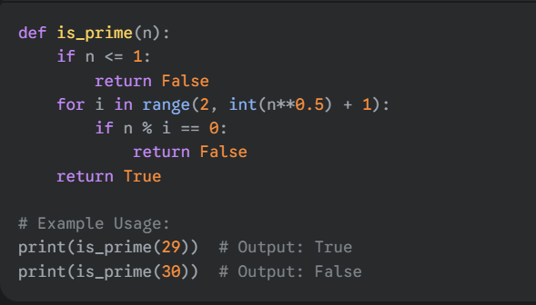

**CODE EXPLANATION:**

• Def is_prime(n):: This defines a function named is_prime that accepts one argument, n, which is the number to be checked.

• If n <= 1:: This is a conditional check. By definition, a prime number must be a natural number greater than 1. This line handles all numbers that are 1 or less (including negative numbers), immediately returning False for them.

• Return False: If the condition n <= 1 is true, the function stops executing and returns False.

• for i in range(2, int(n**0.5) + 1):: This line starts a loop. The loop will iterate through a range of numbers starting from 2 and going up to the integer part of the square root of n. Checking up to the square root is a key optimization.

• If n % i == 0:: Inside the loop, this line checks if n is divisible by the current number i without a remainder. If the remainder is 0, it means i is a factor of n.

• return False: If a factor is found, n cannot be prime, so the function immediately returns False and stops.

Return True: This line is only reached if the loop completes without finding any factors. If no factors were found, the number is a prime, and the function returns True.

PROMPT 02:

Generate a Python function code that takes age as input and returns where the person is a child, teenager, adult, or senior using if-elif-else

CODE:

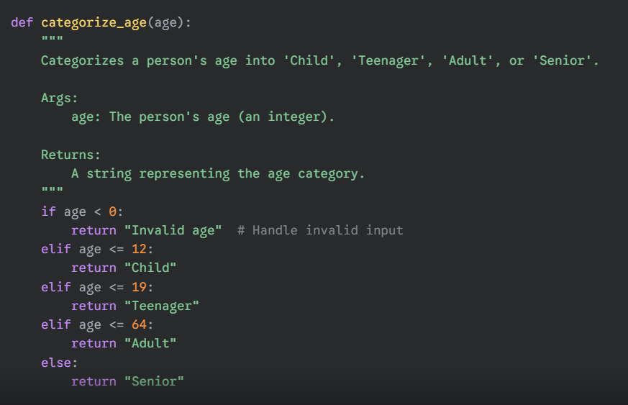

CODE EXPLANATION:

This Python function, categorize_age, uses a series of **if-elif-else statements** to determine a person's life stage based on their age.

* **if age < 0**: This first condition checks for **invalid input**. An age cannot be a negative number, so the function returns an "Invalid age" message.
* **elif age <= 12**: The elif (else if) statement is checked if the first condition is false. It checks if the age is 12 or younger. If so, it returns "Child".
* **elif age <= 19:**: This condition is checked next. Since the previous condition already handled ages up to 12, this one will only apply to ages between 13 and 19 (inclusive), which are categorized as "Teenager".
* **elif age <= 64**: Similarly, this checks for ages between 20 and 64, returning "Adult" if the condition is met.
* **else**: If none of the previous conditions are true, the else block is executed. This means the age is 65 or older, so the function returns "Senior".

This structure ensures that each age falls into one and only one category, processed in a clear, sequential order.

OUTPUT:

